**MODULE: 2 (JavaScript Essentials)**

**1.HTML-CSS Login Registration page**

**Ans.**

**Html code:**

<!DOCTYPE html>

<!---Coding By CoderGirl | www.codinglabweb.com--->

<html lang="en">

<head>

  <meta charset="UTF-8">

  <meta name="viewport" content="width=device-width, initial-scale=1.0">

  <meta http-equiv="X-UA-Compatible" content="ie=edge">

  <!--<title>Login & Registration Form | CoderGirl</title>-->

  <!---Custom CSS File--->

  <link rel="stylesheet" href="style.css">

</head>

<body>

    <!-- start login form -->

  <div class="container">

    <input type="checkbox" id="check">

    <div class="login form">

      <header>Login</header>

      <form action="#">

        <input type="text" placeholder="Enter your email">

        <input type="password" placeholder="Enter your password">

        <a href="#">Forgot password?</a>

        <input type="button" class="button" value="Login">

      </form>

      <div class="signup">

        <span class="signup">Don't have an account?

         <label for="check">Signup</label>

        </span>

      </div>

    </div>

    <!-- end log in form -->

    <!-- start registration form -->

    <div class="registration form">

      <header>Signup</header>

      <form action="#">

        <input type="text" placeholder="Enter your email">

        <input type="password" placeholder="Create a password">

        <input type="password" placeholder="Confirm your password">

        <input type="button" class="button" value="Signup">

      </form>

      <div class="signup">

        <span class="signup">Already have an account?

         <label for="check">Login</label>

        </span>

      </div>

    </div>

    <!-- end registration form -->

  </div>

</body>

</html>

**Css code:**

/* Import Google font - Poppins */

@import url('https://fonts.googleapis.com/css2?family=Poppins:wght@200;300;400;500;600;700&display=swap');

*{

  margin: 0;

  padding: 0;

  box-sizing: border-box;

  font-family: 'Poppins', sans-serif;

}

body{

  min-height: 100vh;

  width: 100%;

  background: #a7afae;

}

.container{

  position: absolute;

  top: 50%;

  left: 50%;

  transform: translate(-50%,-50%);

  max-width: 430px;

  width: 100%;

  background: #fff;

  border-radius: 7px;

  box-shadow: 0 5px 10px rgba(0,0,0,0.3);

}

.container .registration{

  display: none;

}

#check:checked ~ .registration{

  display: block;

}

#check:checked ~ .login{

  display: none;

}

#check{

  display: none;

}

/* form start */

.container .form{

  padding: 2rem;

}

.form header{

  font-size: 2rem;

  font-weight: 500;

  text-align: center;

  margin-bottom: 1.5rem;

}

 .form input{

   height: 60px;

   width: 100%;

   padding: 0 15px;

   font-size: 17px;

   margin-bottom: 1.3rem;

   border: 1px solid #ddd;

   border-radius: 6px;

   outline: none;

 }

 .form input:focus{

   box-shadow: 0 1px 0 rgba(0,0,0,0.2);

 }

.form a{

  font-size: 16px;

  color: #009579;

  text-decoration: none;

}

.form a:hover{

  text-decoration: underline;

}

.form input.button{

  color: #fff;

  background: #77807e;

  font-size: 1.2rem;

  font-weight: 500;

  letter-spacing: 1px;

  margin-top: 1.7rem;

  cursor: pointer;

  transition: 0.4s;

}

.form input.button:hover{

  background: #006653;

}

/* form end */

/* signup start */

.signup{

  font-size: 17px;

  text-align: center;

}

.signup label{

  color: #009579;

  cursor: pointer;

}

.signup label:hover{

  text-decoration: underline;

}

/* signup end */

**Output:**

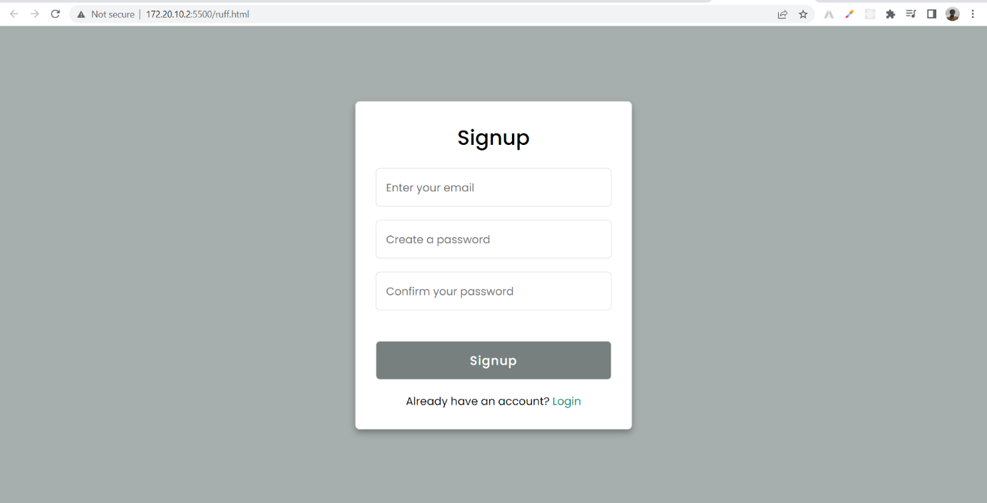

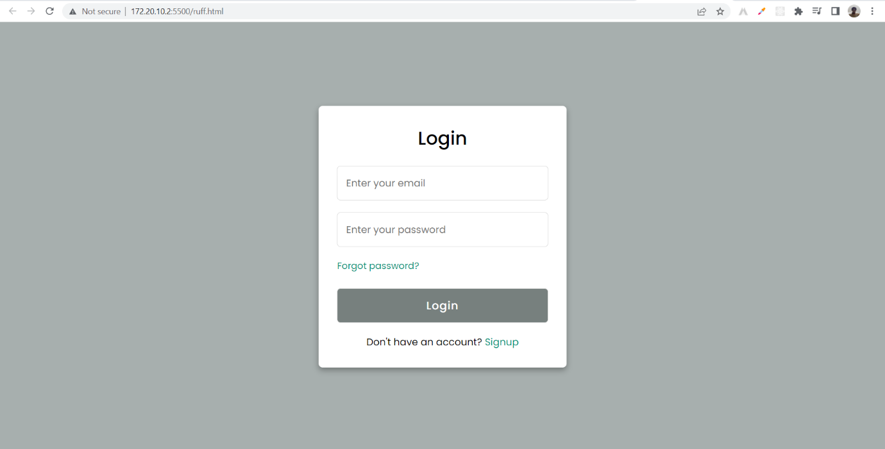

**2. Calculate subtotal price of quantity in JavaScript?**

**Ans.**

**Input:**

<!DOCTYPE html>

<html lang="en">

<head>

    <meta charset="UTF-8">

    <meta http-equiv="X-UA-Compatible" content="IE=edge">

    <meta name="viewport" content="width=device-width, initial-scale=1.0">

    <title>Document</title>

</head>

<style>

</style>

<body>

  <!-- table start -->

    <Table border="1px">

        <tr>

            <th>Product Info</th>

            <th>Image</th>

            <th>Quantity</th>

            <th>Price(per unit)</th>

            <th>Price(Total)</th>

        </tr>

        <tr>

            <td>Sandisk Pandrive</td>

            <!-- sandisk pandrive link -->

            <td><img src="https://m.media-amazon.com/images/I/71qOWNxv4jL._SL1500_.jpg" width="100px"alt=""></td>

            <td><input type="text" id="pandrive_input"></td>

            <td id="pandrive_price">1200</td>

            <td><span id="pandrive"></span></td>

        </tr>

        <tr>

            <td>Sandisk cardreader</td>

            <!-- sandisk cardreader link -->

            <td><img src="https://encrypted-tbn0.gstatic.com/images?q=tbn:ANd9GcQfbxhCLvyZGyF7dpDVqNUjUUOuUFiZT3CzVCBSPaIhgw&usqp=CAU&ec=48665701" alt="" width="100px"></td>

            <td><input type="text" id="cardreader_input" onkeypress="math2()"></td>

            <td id="cardreader_price">300</td>

            <td><span id="cardreader"></span></td>

        </tr>

        <tr>

            <td colspan="4"><input type="submit" onclick="math1()"></td>

        </tr>

    </Table>

    <!-- table end -->

    <script>

      // pandrive Qty function start

        function math1(){

            let price_1=document.getElementById('pandrive_price').innerHTML

            let input_1=document.getElementById('pandrive_input').value

            let span_1=document.getElementById('pandrive')

            let price_1_1=parseInt(price_1)

            let num_1=parseInt(input_1)

            let total=(num_1*price_1_1)

            span_1.innerHTML=total

            // pandrive  Qty function end

            // cardreader Qty function start

            let price_2=document.getElementById('cardreader_price').innerHTML

            let input_2=document.getElementById('cardreader_input').value

            let span_2=document.getElementById('cardreader')

            let price_2_2=parseInt(price_2)

            let num_2=parseInt(input_2)

            let total2=(num_2*price_2_2)

            span_2.innerHTML=total2

            // cardreader function end

        }

    </script>

</body>

</html>

**OutPut:**

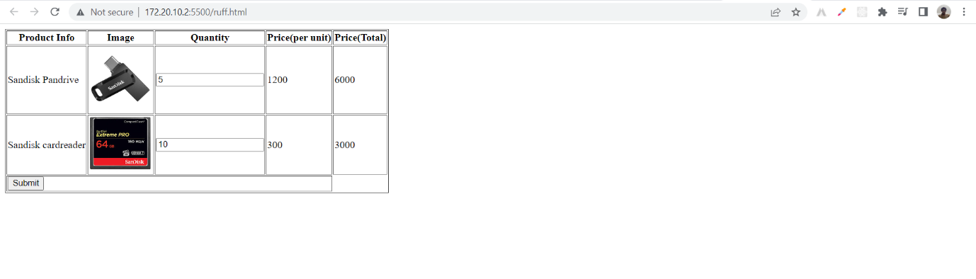

**3. What is JavaScript Output method?**

## Ans. JavaScript Display Possibilities

JavaScript can "display" data in different ways:

* Writing into an alert box, using **window.alert()**.
* Writing into the HTML output using **document.write()**.
* Writing into an HTML element, using **innerHTML**.
* Writing into the browser console, using **console.log()**.

## Using window.alert()

You can use an alert box to display data:

**Input:**

<!DOCTYPE html>

<html lang="en">

<head>

  <meta charset="UTF-8">

  <meta http-equiv="X-UA-Compatible" content="IE=edge">

  <meta name="viewport" content="width=device-width, initial-scale=1.0">

  <title>Document</title>

</head>

<body>

<h1>My First Web Page</h1>

<p>My first paragraph.</p>

<!-- alret count function  -->

<script>

window.alert(5 + 6);

</script>

</body>

</html>

</body>

</html>

**OutPut:**

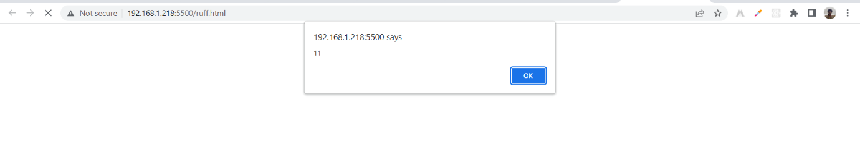

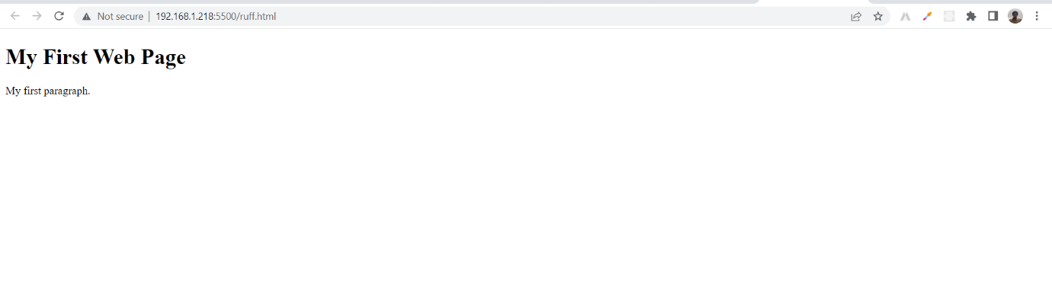

## Using document.write()

For testing purposes, it is convenient to use **document.write()**:

**Input:**

<!DOCTYPE html>

<html lang="en">

<head>

  <meta charset="UTF-8">

  <meta http-equiv="X-UA-Compatible" content="IE=edge">

  <meta name="viewport" content="width=device-width, initial-scale=1.0">

  <title>Document</title>

</head>

<body>

  <h1>My First Web Page</h1>

  <p>My first paragraph.</p>

  <!-- document function -->

  <script>

  document.write(5 + 6);

  </script>

</body>

</html>

</body>

</html>

**OutPut:**

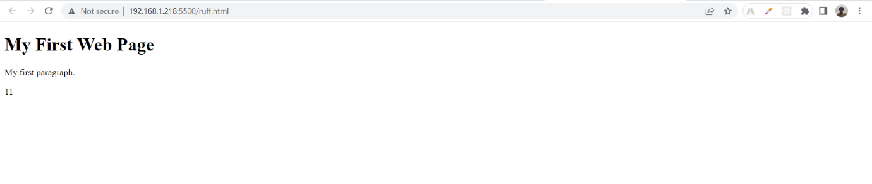

Using document.write() after an HTML document is fully loaded, will **delete all existing HTML**:

**Input:**

<!DOCTYPE html>

<html lang="en">

<head>

  <meta charset="UTF-8">

  <meta http-equiv="X-UA-Compatible" content="IE=edge">

  <meta name="viewport" content="width=device-width, initial-scale=1.0">

  <title>Document</title>

</head>

<body>

  <h1>My First Web Page</h1>

<p>My first paragraph.</p>

<!-- button try function -->

<button onclick="document.write(5 + 6)">Try it</button>

</body>

</html>

</body>

</html>

**OutPut:**

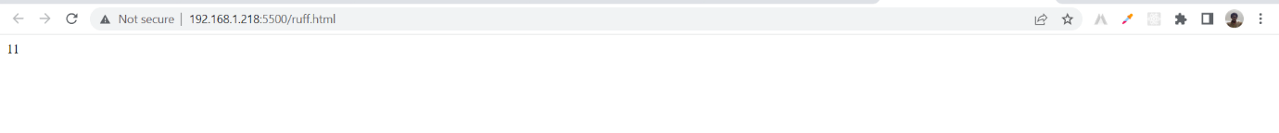

## Using innerHTML

To access an HTML element, JavaScript can use the **document.getElementById(id)** method.

The **id** attribute defines the HTML element. The **innerHTML** property defines the HTML content:

**Input:**

<!DOCTYPE html>

<html lang="en">

<head>

  <meta charset="UTF-8">

  <meta http-equiv="X-UA-Compatible" content="IE=edge">

  <meta name="viewport" content="width=device-width, initial-scale=1.0">

  <title>Document</title>

</head>

<body>

  <h1>My First Web Page</h1>

<p>My First Paragraph</p>

<p id="demo"></p>

<!-- demo function -->

<script>

document.getElementById("demo").innerHTML = 5 + 6;

</script>

</body>

</html>

</body>

</html>

**OutPut:**

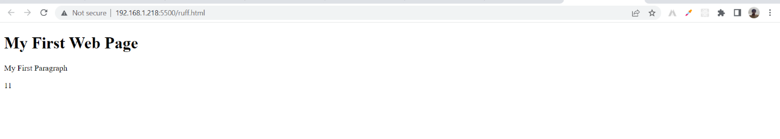

## Using console.log()

In your browser, you can use the **console.log()** method to display data.

Activate the browser console with F12, and select "Console" in the menu.

**Input:**

<!DOCTYPE html>

<html lang="en">

<head>

  <meta charset="UTF-8">

  <meta http-equiv="X-UA-Compatible" content="IE=edge">

  <meta name="viewport" content="width=device-width, initial-scale=1.0">

  <title>Document</title>

</head>

<body>

  <h1>My First Web Page</h1>

  <p>My first paragraph.</p>

  <!-- console function -->

  <script>

  console.log(5 + 6);

  </script>

</body>

</html>

</body>

</html>

**OutPut:**

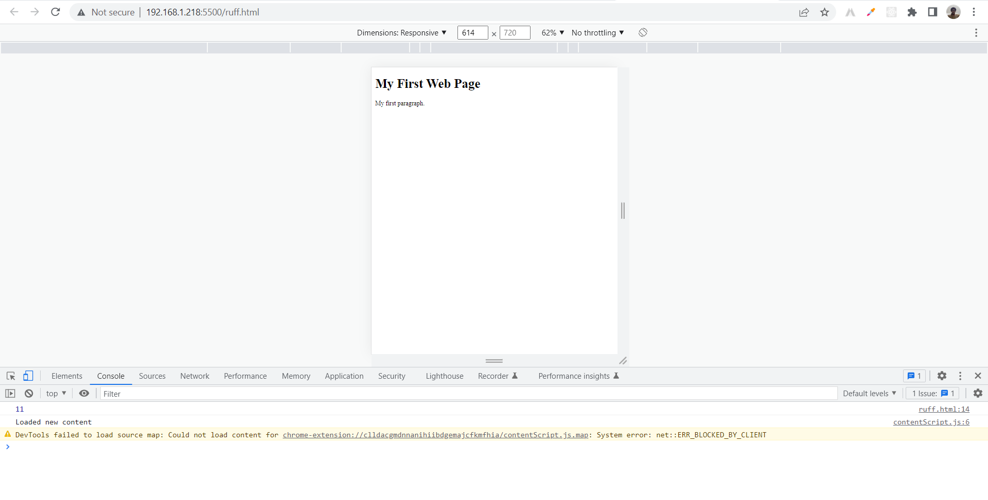

**4. How to used JavaScript Output method?**

**Ans.** JavaScript Output defines the ways to display the output of a given code. The output can be displayed by using four different ways which are listed below:

1. [**innerHTML**](https://www.geeksforgeeks.org/html-dom-innerhtml-property/)**:** It is used to access an element. It defines the HTML content.

**Syntax:**

document.getElementById("id").innerHTML;

**Input:**

<!DOCTYPE html>

<html lang="en">

<head>

  <meta charset="UTF-8">

  <meta http-equiv="X-UA-Compatible" content="IE=edge">

  <meta name="viewport" content="width=device-width, initial-scale=1.0">

  <title>Document</title>

</head>

<body>

  <h1>Top technology</h1>

<h2>

  JavaScript Display Possibilities

  Using innerHTML

</h2>

<p id="TOP"></p>

<!-- Script to use innerHTML -->

<script>

  document.getElementById("TOP").innerHTML

    = 10 * 2;

</script>

</body>

</html>

**Output**

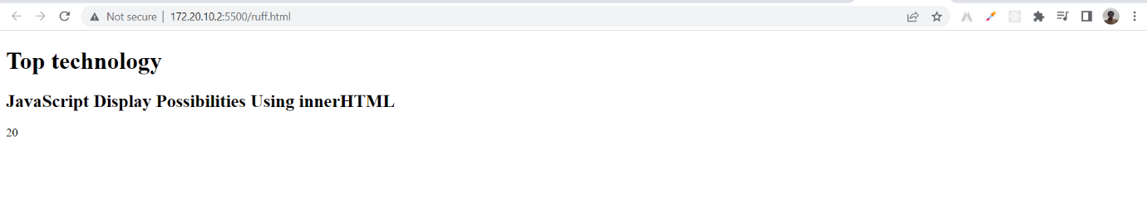

**2.**[**document.write()**](https://www.geeksforgeeks.org/html-dom-write-method/)**:** It is used for testing purpose.

**Syntax:**

document.write()

**Input:**

<!DOCTYPE html>

<html lang="en">

<head>

  <meta charset="UTF-8">

  <meta http-equiv="X-UA-Compatible" content="IE=edge">

  <meta name="viewport" content="width=device-width, initial-scale=1.0">

  <title>Document</title>

</head>

<body>

  <h1>Top technology</h1>

<h2>

      JavaScript Display Possibilities

     Using document.write()

</h2>

<p id="TOP"></p>

<!-- Script to uses document.write() -->

<script>

      document.write(10 * 2);

</script>

</body>

</html>

**Output:**

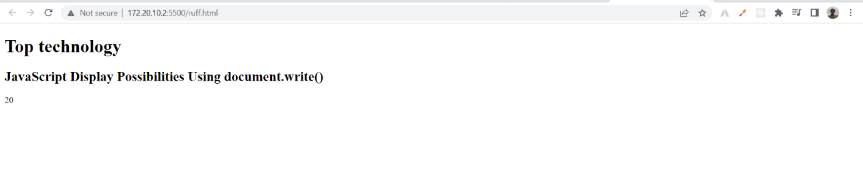

1. [**window.alert()**](https://www.geeksforgeeks.org/html-window-alert-method/)**:**It displays the content using an alert box.

window.alert()

**Input:**

<!DOCTYPE html>

<html lang="en">

<head>

  <meta charset="UTF-8">

  <meta http-equiv="X-UA-Compatible" content="IE=edge">

  <meta name="viewport" content="width=device-width, initial-scale=1.0">

  <title>Document</title>

</head>

<body>

  <h1>Top Technology</h1>

<h2>

      JavaScript Display Possibilities

      Using window.alert()

</h2>

<p id="TOP"></p>

<!-- Script to use window.alert() -->

<script>

    window.alert(10 * 2);

</script>

</body>

</html>

**Output:**

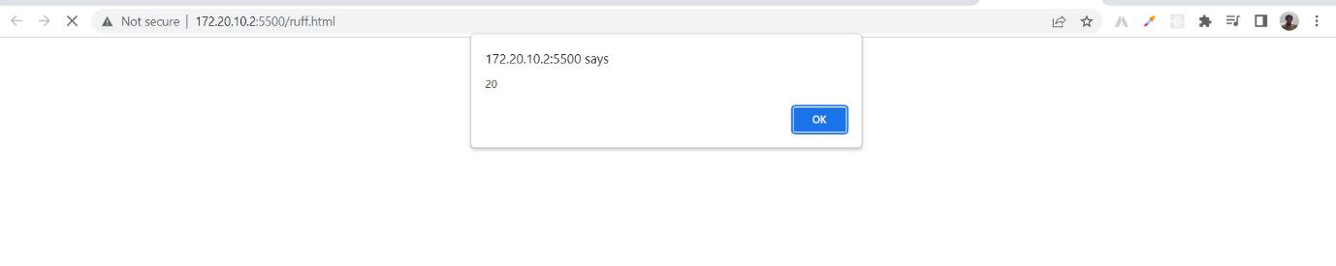

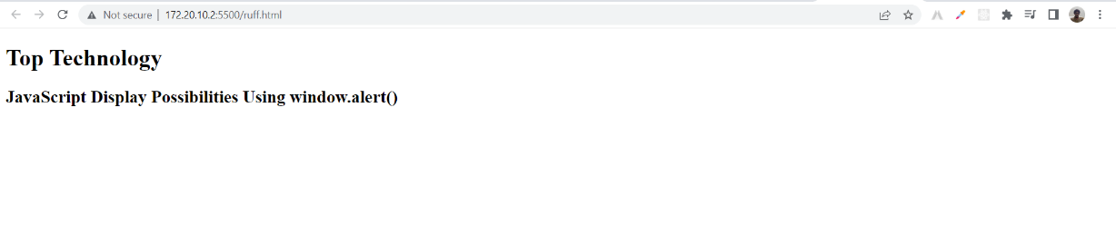

1. [**console.log()**](https://www.geeksforgeeks.org/javascript-console-log-method/)**:** It is used for debugging purposes.

**Syntax:**

console.log()

**Input:**

<!DOCTYPE html>

<html lang="en">

<head>

  <meta charset="UTF-8">

  <meta http-equiv="X-UA-Compatible" content="IE=edge">

  <meta name="viewport" content="width=device-width, initial-scale=1.0">

  <title>Document</title>

</head>

<body>

  <h1>Top Technology</h1>

<h2>

    JavaScript Display Possibilities

    Using console.log()

</h2>

<p id="TOP"></p>

<!-- Script to use console.log() -->

<script>

    console.log(10*2);

</script>

</body>

</html>

**Output:**

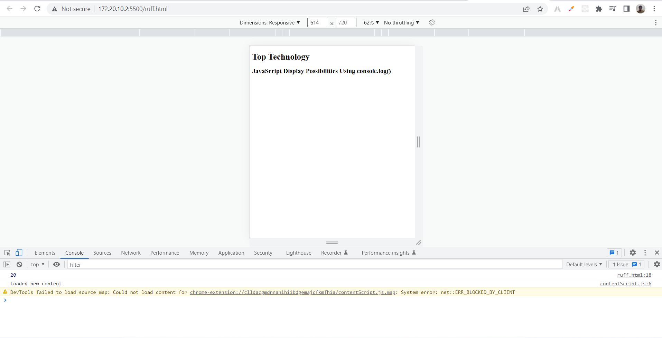

**5.How to used JavaScript Events to do all examples?**

**Ans.**

### **Onclick Events and Syntax**

We can define it as a mouse event that stimulates as per the code logic you determine in your code. Here is the code snippet we can use.

**Input:**

<!DOCTYPE html>

<html lang="en">

<head>

    <meta charset="UTF-8">

    <meta http-equiv="X-UA-Compatible" content="IE=edge">

    <meta name="viewport" content="width=device-width, initial-scale=1.0">

    <title>Document</title>

    <!-- alret function -->

    <script>

        function Greet() {

          alert('Hello World!');

        }

      </script>

</head>

<body>

  <!-- button function -->

    <button type="button" onclick="Greet()">Please click here! </button>

</body>

</html>

**Output:**

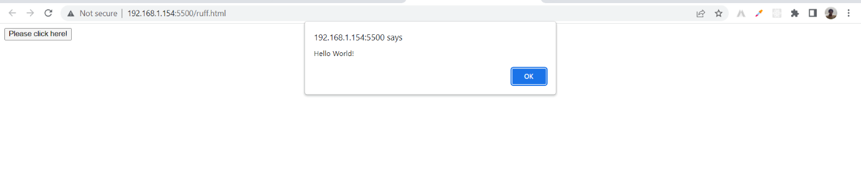

### **Onkeyup Event and Syntax**

You can use this Javascript event in a scenario where you press a keyboard event and it performs as per your code logic. We can use the below code snippet.

**Input:**

<!DOCTYPE html>

<html lang="en">

<head>

    <meta charset="UTF-8">

    <meta http-equiv="X-UA-Compatible" content="IE=edge">

    <meta name="viewport" content="width=device-width, initial-scale=1.0">

    <title>Document</title>

</head>

<body>

    Enter your First name: <input type="text" id="firstname" onkeyup="myKeyUpFunction()">

    <p>My First name is: <span id="Test"></span></p>

    <script>

      // key function

        function myKeyUpFunction() {

          var input = document.getElementById("firstname").value;

          document.getElementById("Test").innerHTML = input;

        }

        </script>

</body>

</html>

**Output:**

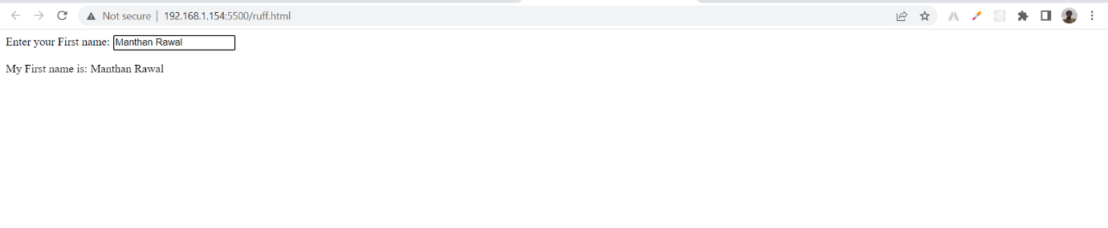

### **Onmouseover Event and Syntax**

We can use this event for hovering the mouse pointer when we put the cursor and it performs as per the logic of the element which is connected to and its child's elements. We can use the below code snippet.

**Input:**

<!DOCTYPE html>

<html lang="en">

<head>

    <meta charset="UTF-8">

    <meta http-equiv="X-UA-Compatible" content="IE=edge">

    <meta name="viewport" content="width=device-width, initial-scale=1.0">

    <title>Document</title>

</head>

<h1 id="demo">Test Mouse over me</h1>

<script>

// mouse over function

document.getElementById("demo").onmouseover = function() {mouseOver()};

function mouseOver() {

  document.getElementById("demo").style.color = "Purple";

}

</script>

</body>

</html>

**Output:**

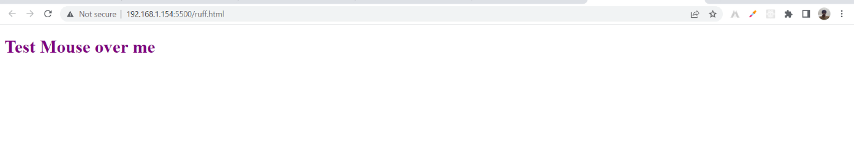

### **Onmouseout Event**

When you leave the mouse cursor it moves to the element that controls a mouseout event;, a function associated with it is executed. The below code snippet can help you to understand the logic.

**Input:**

V<!DOCTYPE html>

<html lang="en">

<head>

    <meta charset="UTF-8">

    <meta http-equiv="X-UA-Compatible" content="IE=edge">

    <meta name="viewport" content="width=device-width, initial-scale=1.0">

    <title>Document</title>

</head>

<h1 id="demo">Test Mouse over me</h1>

<script>

// mouse out function

document.getElementById("demo").onmouseout = function() {mouseOut()};

function mouseOut() {

  document.getElementById("demo").style.color = "Red";

}

</script>

</body>

</html>

**Output:**

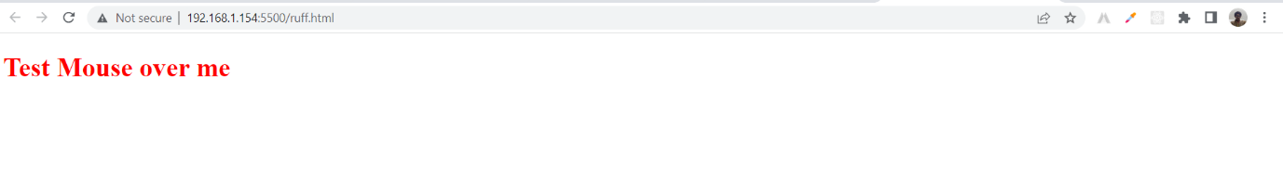

### **Onchange Event and Syntax**

This event identifies the variance in the value of any element listing to this event. The best example of this is when text and dropdown list change events. The below code snippet can help you understand the logic as to how it converts the input name with the upper case when text changes.

**Input:**

<!DOCTYPE html>

<html lang="en">

<head>

    <meta charset="UTF-8">

    <meta http-equiv="X-UA-Compatible" content="IE=edge">

    <meta name="viewport" content="width=device-width, initial-scale=1.0">

    <title>Document</title>

</head>

Please Enter name: <input type="text" id="Firstname">

<script>

  // uppercase function

document.getElementById("Firstname").onchange = function() {myFunction()};

function myFunction() {

  var x = document.getElementById("Firstname");

  x.value = x.value.toUpperCase();

}

</script>

</body>

</html>

**Output:**

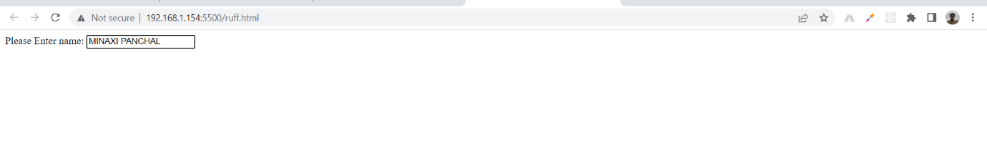

### **Onload Event and Syntax**

The JavaScript onload event can be utilized when we have a specific requirement to execute a specific function once the page is represented fully. The below code snippet can help you understand the logic.

**Input:**

<!DOCTYPE html>

<html lang="en">

<head>

    <meta charset="UTF-8">

    <meta http-equiv="X-UA-Compatible" content="IE=edge">

    <meta name="viewport" content="width=device-width, initial-scale=1.0">

    <title>Document</title>

</head>

<body onload="checkyourCookies()">

    <p id="OnloadTest"></p>

    <script>

      // cookies function

    function checkyourCookies() {

      var text = "";

      if (navigator.cookieEnabled == true) {

        text = "your web page Cookies are active.";

      } else {

        text = "your web page Cookies are not active.";

      }

      document.getElementById("OnloadTest").innerHTML = text;

    }

    </script>

    </body>

</html>

**Output:**

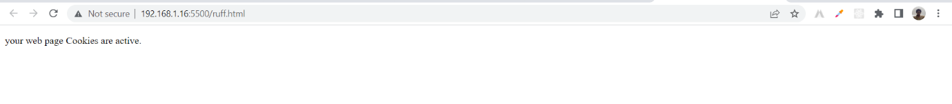

### **Onfocus Event and Syntax**

This Javascript function performs when the given instruction receives the focus as per the change or click event. The below code snippet can help you understand the logic.

**Input:**

<!DOCTYPE html>

<html lang="en">

<head>

    <meta charset="UTF-8">

    <meta http-equiv="X-UA-Compatible" content="IE=edge">

    <meta name="viewport" content="width=device-width, initial-scale=1.0">

    <title>Document</title>

</head>

<body>

    <p>This is the best scenario to uses the addEventListener() function to attach a "focus" event to an input element box.</p>

Enter your First name: <input type="text" id="Firstname">

<script>

  // dark blue function

document.getElementById("Firstname").addEventListener("focus", myFunction);

function myFunction() {

  document.getElementById("Firstname").style.backgroundColor = "DarkBlue";

}

</script>

    </body>

</html>

**Output:**

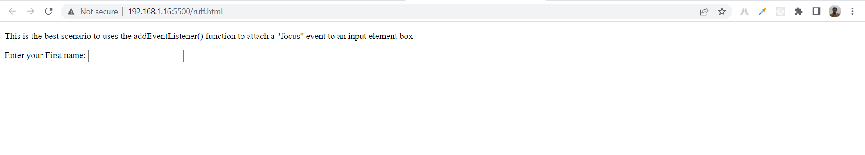

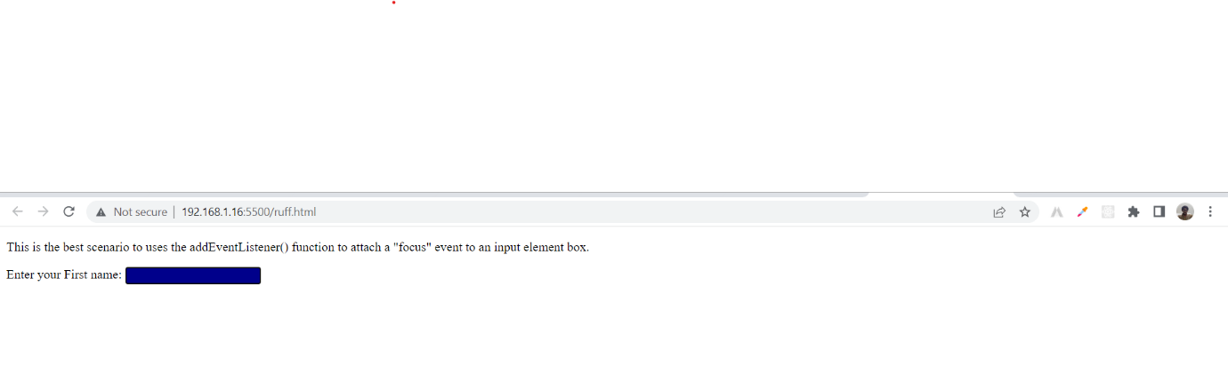

### **Onblur Event and Syntax**

This Javascript Onblur event triggers when a certain object loses focus. We can execute the below code to understand how to implement it.

**Input:**

<!DOCTYPE html>

<html lang="en">

<head>

    <meta charset="UTF-8">

    <meta http-equiv="X-UA-Compatible" content="IE=edge">

    <meta name="viewport" content="width=device-width, initial-scale=1.0">

    <title>Document</title>

</head>

<body>

    <p>This code snippet uses the addEventListener() method and performs a "blur" event to an input element.</p>

<p>please write something and see the result (blur).</p>

<input type="text" id="fname">

<script>

document.getElementById("fname").addEventListener("blur", myFunction);

// alert function lost focus

function myFunction() {

  alert("your Input element lost focus.");

}

</script>

    </body>

</html>

**Output:**

